# File permissions in Linux

## Project description

The research team at my organization needs to update the file permissions for certain files and directories within the **projects** directory. The permissions do not currently reflect the level of authorization that should be given. Checking and updating these permissions will help keep their system secure. To complete this task, I performed the following tasks:

## Check file and directory details

The following code demonstrates how I used Linux commands to determine the existing permissions set for a specific directory in the file system.

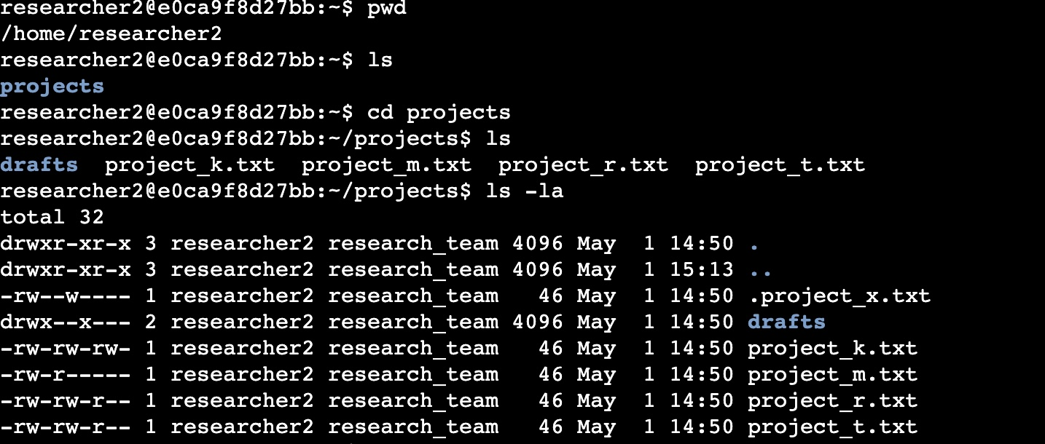

The code lists all contents of the **projects** directory. I used the **pwd** command to find out which directory I was in, I then used the **cd** command to navigate to the projects directory, I used the **ls** command with the **-la** option to display a detailed listing of the file contents that also returned hidden files. The output of my command indicates that there is one directory named **drafts**, one hidden file named.**project_x.txt**, and five other project files. The 10-character string in the first column represents the permissions set on each file or directory.

## Describe the permissions string

The 10-character string can be deconstructed to determine who is authorized to access the file and their specific permissions. The characters and what they represent are as follows:

* **1st character**: This character is either a **d** or hyphen (**-**) and indicates the file type. If it’s a **d**, it’s a directory. If it’s a hyphen (-), it’s a regular file.
* **2nd-4th characters**: These characters indicate the read (**r)**, write (**w**), and execute (**x**) permissions for the user. When one of these characters is a hyphen (**-**) instead, it indicates that this permission is not granted to the user.
* **5th-7th characters:** These characters indicate the read (**r)**, write (**w**), and execute (**x**)permissions for the group. When one of these characters is a hyphen (**-**) instead, it indicates that this permission is not granted for the group.
* **8th-10th characters:** These characters indicate the read (**r)**, write (**w**), and execute (**x**) permissions for other. This owner type consists of all other users on the system apart from the user and the group. When one of these characters is a hyphen (**-**) instead, that indicates that this permission is not granted for other.

For example, the file permissions for **project_t.txt (refer to the screenshot of the code)** are

**-rw-rw-r--.** Since the first character is a hyphen **(-),** this indicates that **project_t.txt** is a file, not a directory. The second, fifth, and eighth characters are all r, which indicates that user, group, and other all have read permissions. The third and sixth characters are **w**, which indicates that only the user and group have write(**W**) permissions. No one has execute(**X**) permissions for **project_t.txt.**

## Change file permissions

The organization determined that other shouldn't have write access to any of their files. To comply with this, I referred to the file permissions that I previously returned. I determined **project_k.txt** must have the write access removed for other. The organization also decided that group shouldn’t have read access to **project_m.txt**

The following code demonstrates how I used Linux commands to do this:

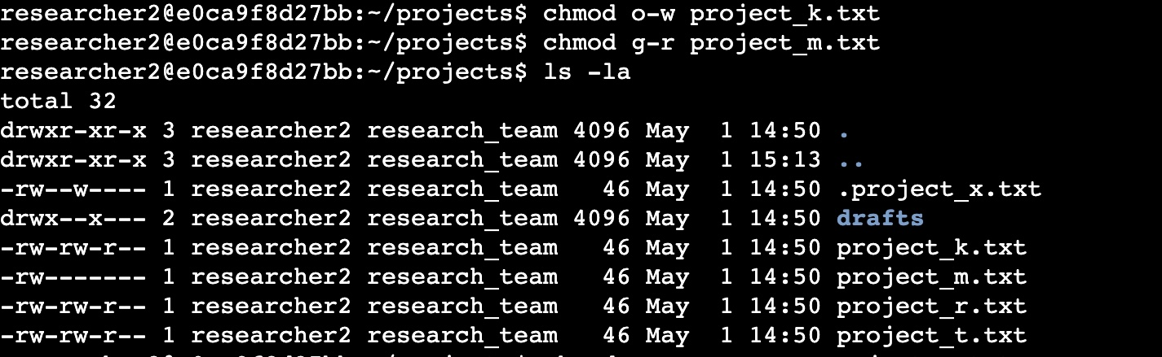  
The first two lines of the screenshot display the commands I entered, and the other lines display the output of the second command. The **chmod** command changes the permissions on files and directories. The first argument indicates what permissions should be changed, and the second argument specifies the file or directory. In this example, I removed write permissions from other for the **project_k.txt** and read permissions for the **project_m**.txt files. After this, I used **ls -la** to review the updates I made.

## Change file permissions on a hidden file

The research team at my organization recently archived **project_x.txt**. They do not want anyone to have write access to this project, but the user and group should have read access.

The following code demonstrates how I used Linux commands to change the permissions:

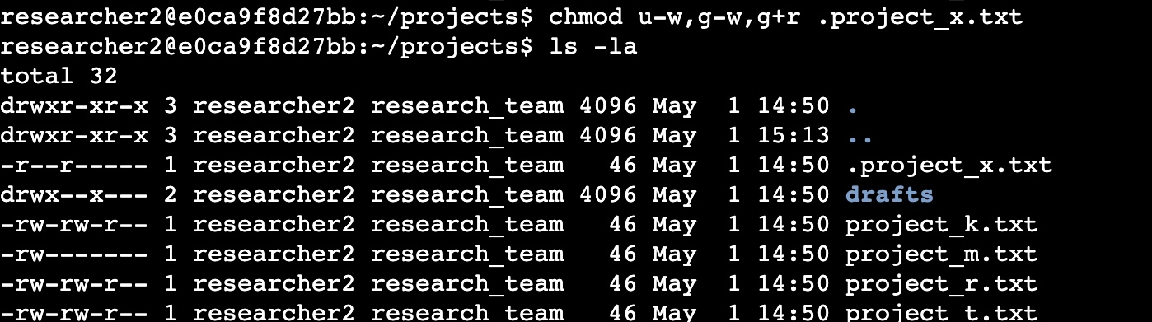

The first two lines of the screenshot display the commands I entered, and the other lines display the output of the second command. I know .**project_x.txt** is a hidden file because it starts with a period **(.).** In this example, I removed write permissions from the user and group, and added read permissions to the group. I removed write permissions from the user with **u-w.** Then, I removed write permissions from the group with **g-w**, and added read permissions to the group with **g+r**.

## Change directory permissions

My organization only wants the **researcher2** user to have access to the **drafts** directory and its contents. This means that no one other than **researcher2** should have execute permissions.

The following code demonstrates how I used Linux commands to change the permissions:

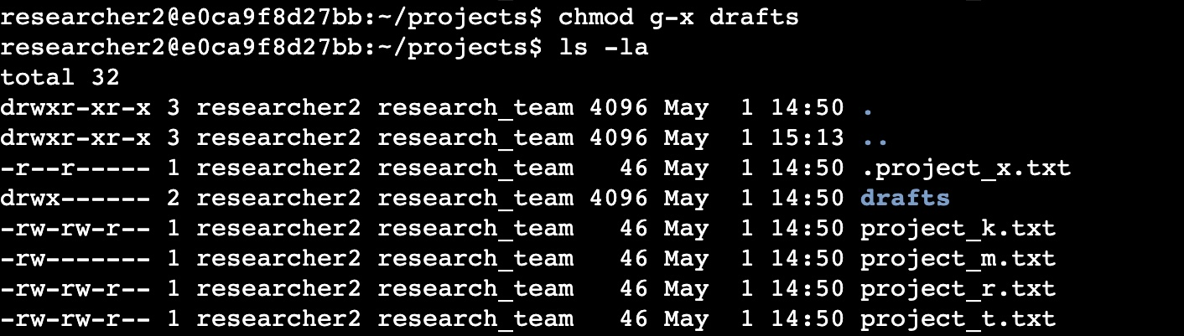

The first two lines of the screenshot display the commands I entered, and the other lines display the output of the second command. I previously determined that the group had execute permissions, so I used the **chmod** command to remove them. The **researcher2** user already had execute permissions, so they did not need to be added.

## Summary

I changed multiple permissions to match the level of authorization my organization wanted for files and directories in the **projects** directory. The first step in this was using **ls -la** to check the permissions for the directory. This informed my decisions in the following steps. I then used the **chmod** command multiple times to change the permissions on files and directories.